Electric Petrol WAN & LAN Prototype

Executive Summary
Electric Petrol has expanded its retail fuel operations to over 60 service stations nationwide. Following the successful deployment of site LAN infrastructures (Phase 1), the company now requires a nationwide WAN interconnecting:
- Head Office (Dublin)
- Data Centre 1 (Mayo)
- Data Centre 2 (Malin)
- Local site (Midleton – student site)
This project delivers a prototype Wide Area Network (WAN) using OSPF across a GNS3 environment.
It also incorporates router-on-a-stick VLAN routing, static /30 WAN links, and routing domain integration.
This document contains the design, implementation, topology diagrams, router configurations, and testing outputs for the final solution.

Network Design Overview
WAN Architecture
The Electric Petrol WAN uses:
- Point-to-Point /30 links
- OSPF Area 0 (Backbone)
- 4 routed sites
- Full IP routing between all site subnets

WAN Topology Diagram
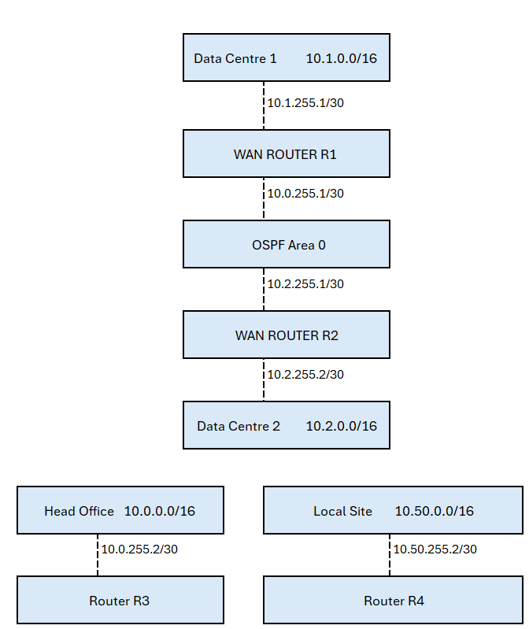

IP Addressing Scheme
Site | Network Block
Head Office | 10.0.0.0/16
Data Centre 1 | 10.1.0.0/16
Data Centre 2 | 10.2.0.0/16
Local Site (Student) | 10.50.0.0/16

WAN /30 Links
Link | Network | R1 | R2 | R3 | R4
DC1 ↔ CORE | 10.1.255.0/30 | 0.1 | 0.2 | — | —
HQ ↔ CORE | 10.0.255.0/30 | — | 0.1 | 0.2 | —
LOCAL ↔ CORE | 10.50.255.0/30 | — | 0.1 | — | 0.2

VLAN Design (LAN Side)
Based on the provided spreadsheet, the following VLANs apply at each site:
- 1 – ISP
- 2 – Hosts
- 3 – Staff Radio
- 4 – Power Infrastructure
- 5 – Technical Clients
- 6 – Infrastructure Servers
- 7 – Telephony
- 8 – HVAC
- 9 – Storage
- 10 – Network Management
- 11 – Security Cameras
- 12 – OOBM
- 13 – Routers
- 15 – Links
These are carried over one 802.1Q trunk per site router.

GNS3 Implementation
Devices Used
- Cisco IOSv 15.9(3)M3 routers

GNS3 Router Configurations
R1 – Data Centre 1 Router
conf t
hostname R1-DC1

interface g0/0
description DC1 LAN
ip address 10.1.0.1 255.255.0.0

interface g0/1
description DC1-to-Core
ip address 10.1.255.1 255.255.255.252

router ospf 1
router-id 1.1.1.1
network 10.1.0.0 0.0.255.255 area 0
network 10.1.255.0 0.0.0.3 area 0
end

R2 – Core Backbone Router
conf t
hostname R2-CORE

interface g0/0
description Core-to-DC1
ip address 10.1.255.2 255.255.255.252

interface g0/1
description Core-to-DC2
ip address 10.2.255.1 255.255.255.252

interface g0/2
description Core-to-HQ
ip address 10.0.255.1 255.255.255.252

interface g0/3
description Core-to-LocalSite
ip address 10.50.255.1 255.255.255.252

router ospf 1
router-id 2.2.2.2
network 10.1.255.0 0.0.0.3 area 0
network 10.2.255.0 0.0.0.3 area 0
network 10.0.255.0 0.0.0.3 area 0
network 10.50.255.0 0.0.0.3 area 0
end

R3 – Head Office Router
conf t
hostname R3-HQ

interface g0/0
description HQ LAN
ip address 10.0.0.1 255.255.0.0

interface g0/1
description HQ-to-Core
ip address 10.0.255.2 255.255.255.252

router ospf 1
router-id 3.3.3.3
network 10.0.0.0 0.0.255.255 area 0
network 10.0.255.0 0.0.0.3 area 0
end

R4 – Local Site Router (Midleton)
conf t
hostname R4-Local

interface g0/0
description Local LAN
ip address 10.50.0.1 255.255.0.0

interface g0/1
description Local-to-Core
ip address 10.50.255.2 255.255.255.252

router ospf 1
router-id 4.4.4.4
network 10.50.0.0 0.0.255.255 area 0
network 10.50.255.0 0.0.0.3 area 0
end

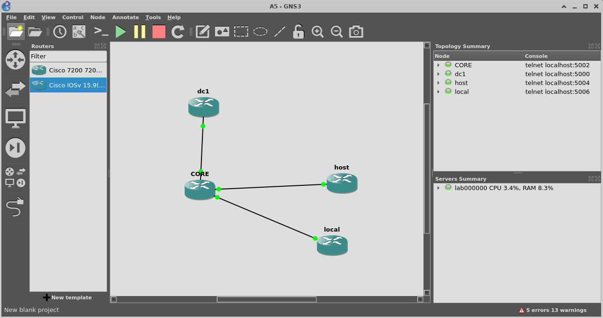
Testing & Verification
show ip ospf neighbor
Expected:
- R1 ↔ R2: FULL
- R3 ↔ R2: FULL
- R4 ↔ R2: FULL

Routing Table Check
show ip route ospf
Expected:
- All four /16 networks reachable
Ping Tests

From R1:
ping 10.0.1.1
ping 10.50.1.1

From R3:
ping 10.1.1.1

Conclusions & Recommendations
This project successfully demonstrates:
- A full layer-3 routed WAN
- OSPF dynamic routing
- Multi-site VLAN architecture
- Router-on-a-stick inter-VLAN routing
- A scalable design suitable for 60+ service stations
Next Steps for Electric Petrol
- Add redundant CORE router for failover
- Introduce OSPF multi-area design for branch scalability
- Utilize MPLS or SD-WAN for real-world WAN deployment
- Extend VLAN templates to all service stations
- Centralize authentication using RADIUS/ISE

